Lab 14
NextGen Firewalls
Cisco FirePower AMP and IPS
Objective:
The purpose of this lab is for the student to understand configuration and implement URL Filtering rules using Cisco Firepower
Diagram:

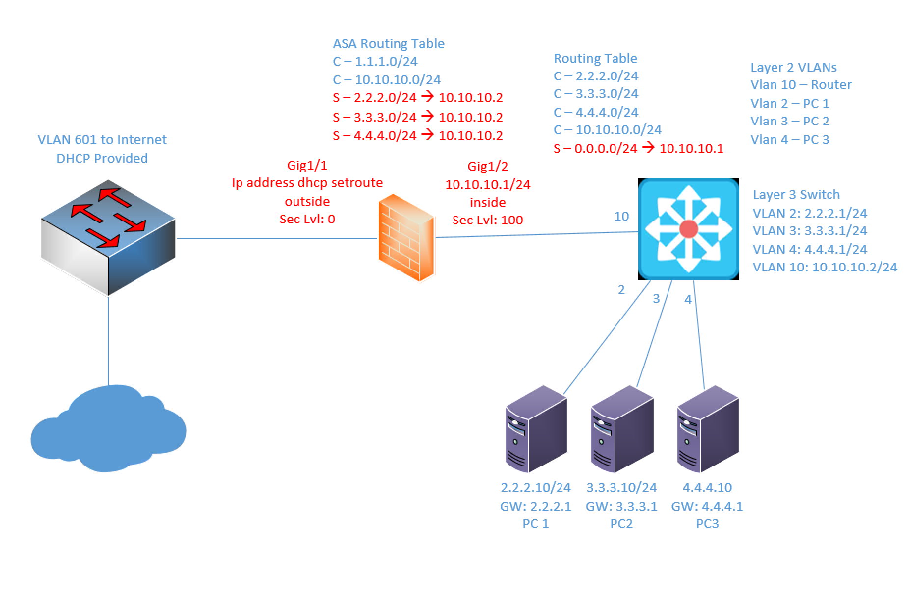

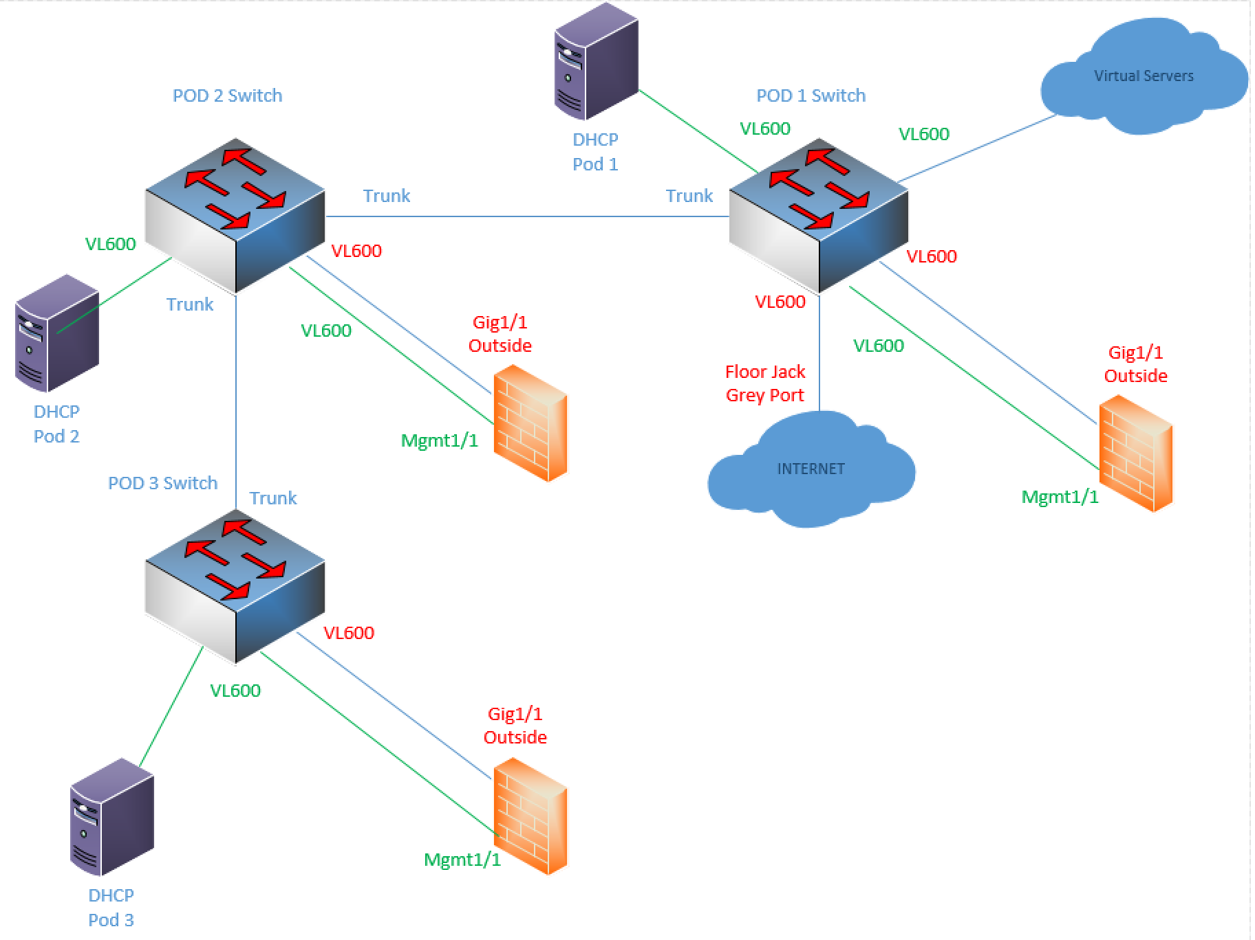
Components:
4 – PCs
1 – Cisco 5516X ASA
1 – Cisco 3650 L3 Switch
1 – Cisco 3650 L2 Switch

Useful commands for this lab
ASA Interface and Routing Config
interface gig 1/1
nameif outside
ip address dhcp setroute
no shutdown
security-level 0

interface gig 1/2
nameif inside
ip address 10.10.10.1 255.255.255.0
no shutdown
security-level 100

route inside 2.2.2.0 255.255.255.0 10.10.10.2
route inside 3.3.3.0 255.255.255.0 10.10.10.2
route inside 4.4.4.0 255.255.255.0 10.10.10.2

object network Two_Network
subnet 2.2.2.0 255.255.255.0
nat (inside,outside) dynamic interface

object network Three_Network
subnet 3.3.3.0 255.255.255.0
nat (inside,outside) dynamic interface

object network Four_Network
subnet 4.4.4.0 255.255.255.0
nat (inside,outside) dynamic interface

Redirect Traffic to FirePower Module
class global-class
match any

policy-map global_policy
class global-class
sfr fail-open

Procedure:
- Connect all PCs, switches and routers as shown in the diagram above.
- Use the configuration above on the ASA
- If you want/need help with the L3 switch, let me know. I want more time spent in the FMC GUI than setting up the physical network.
- Connect to the GUI on your management PC using https://172.30.39.200. I will set up the connection to this network since it’s on the virtual servers in the rack. We’re all using the same Management server, but I set up different users for each pod. Please do not edit any other group’s policies. Pod 1 is by the door. Pod 3 is by the closet. Pod 2 is diagonal from where I sit.

  - Pod1 credentials: netc230pod1\Netcom339
  - Pod2 credentials netc230pod2\Netcom339
  - Pod2 credentials netc230pod3\Netcom339

- Navigate to Policies, Access Control and then Malware & File:
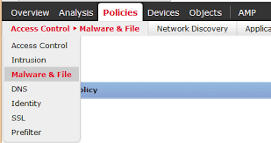

- Click the Add button to add a new Policy. Call the Policy PodXAMP. Replace the X with your pod number. For example, Pod 3’s policy name should be Pod3AMP.
- Once the policy is created, add a new rule. This is the Add rule screen you should be at now:
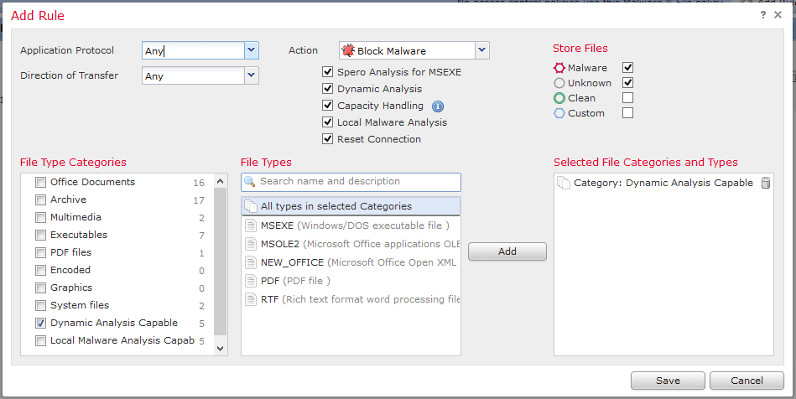

- Here are the parameters for the first rule:
  - Application protocol: Any
  - Direction of Transfer: any
  - Action: Block File
  - File Type Categories: Archive
    - Add this entire category by clicking the checkbox next to Archive and clicking Add button.
  - Click Save
- Click Add to add another rule with the following parameters
  - Application protocol: Any
  - Direction of Transfer: any
  - Action: Block Malware
  - Click all boxes under Action:
    - Spero
    - Dynamic Analysis
    - Capacity Handling
    - Local Malware Analysis
    - Reset Connection
  - File Type Categories: All except Archive
  - Click Save
- We’ll add the AMP policy to the Access Control Policy in a later step.
- Next, we’ll create the IPS rule. Click on Policies, Access-Control, Intrusion.
- Click the Add button to create a new policy. Name the policy PodXIPS where X is your pod number. Pod 2’s IPS policy would be Pod2IPS. Click the checkbox for “Drop when Inline”. Click the drop-down menu for “Base Policy” and select “Balanced Security and Connectivity”. Click Create Policy. Your policy should look something like this:
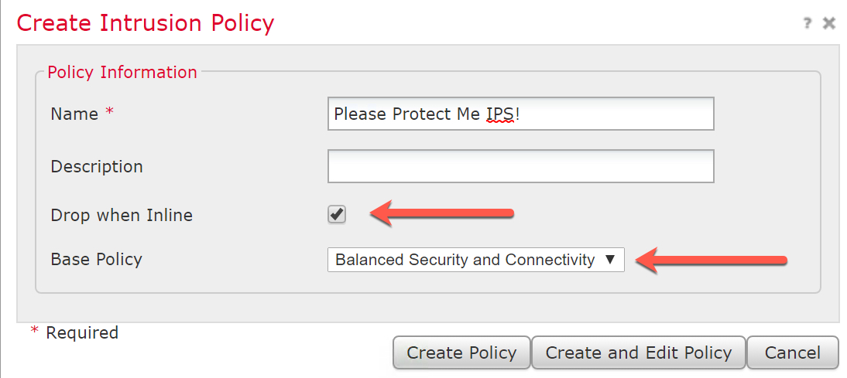

- Click on the name of your policy or the pencil on the right to explore the existing rules and signatures.
- Click on rules and then Category. Click on the Blacklist category. The rules each have an action associated with them. There are only three actions. Find a rule with a red X, a greyed-out arrow and a highlighted arrow, hover over the icon and tell me what the actions are:
  - Red X: Drop and Generate Events
  - greyed out arrow: Disabled
  - Highlighted arrow: Generate Events
- The IPS Rules menu should look something like this:
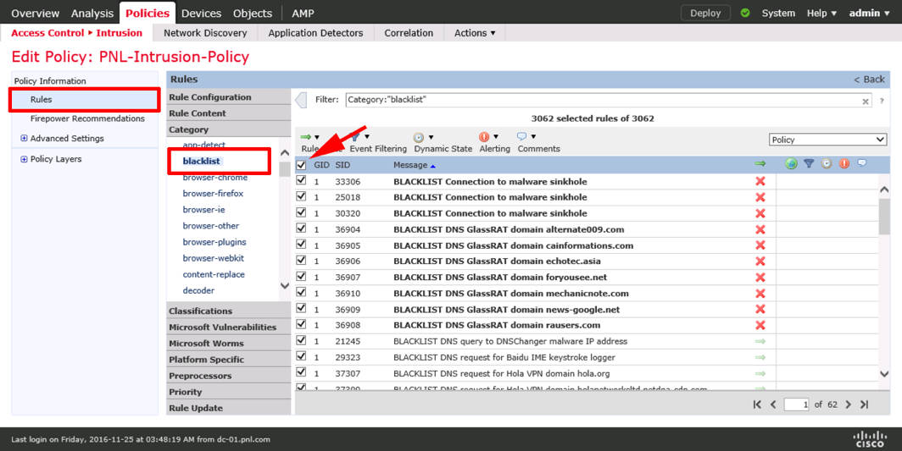

- Now that we have the AMP and IPS rules created, we have to apply them to an access control policy rule. To do this, navigate to Policies, Access-Control, Access-Control. Click on the pencil to edit your rule from previous labs. The last line in your Access policy should be permit all traffic.
- We’re going to edit this rule to allow all traffic as long as it’s safe and passes our AMP and IPS signatures. Click the last rule that’s allowing everything so we can make changes. Click the Inspection tab. Click the drop-down menus to add your IPS and AMP rules. Screen shot this tab and paste below. Then click Add. Should look something like this:
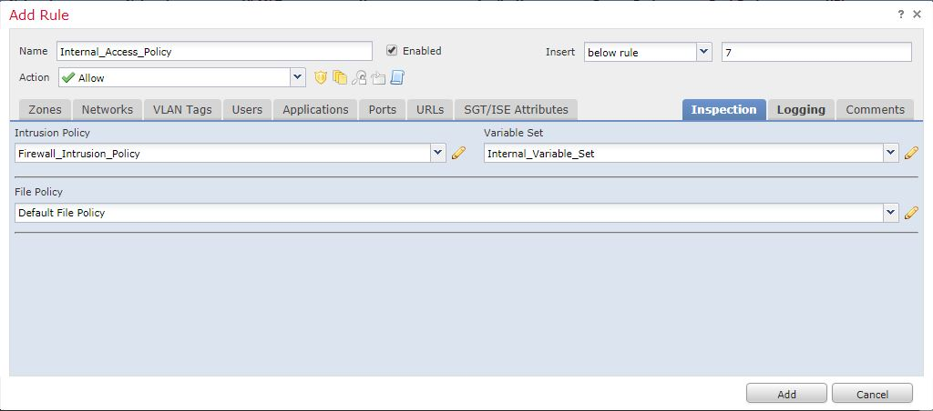

- Click Save and then deploy only to your pod’s policy and device.
- We should be able to test the AMP policy by trying to download a zip/archive file from the internet. From the 2.X network, Browse to: http://tftpd32.jounin.net/tftpd32_download.html
- Click on “direct link for tftpd64 portable edition” near the top of the screen.
  - What happens when you try to download this file? It downloads, but it shouldn’t
  - Which rule is causing this behavior? This should be blocked by the POD3AMP rule
  - Screenshot the result of the download attempt and paste below.
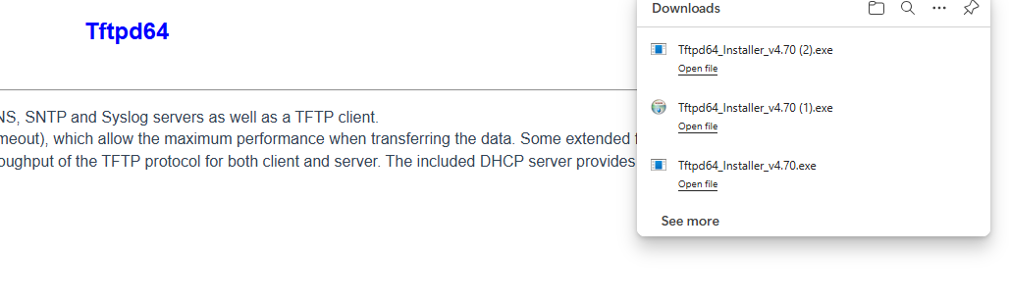
You can see the file downloaded because it was encrypted and FirePower wasn’t set up to decrypt traffic. Otherwise, it should have blocked the download.

- Go back to Analysis, Connection and Events and find your traffic that was blocked. Paste a screenshot below:
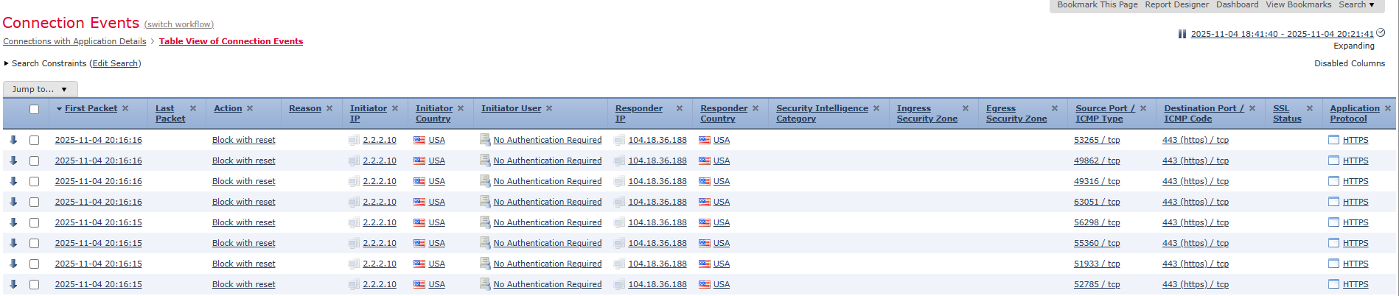

- Draw the lab diagram below (PCs, firewall and switch connections) Label the IP addresses, subnet masks, and gateways used by each device. Label all components, including your FMC and FPMs (manager and module).
